Week 2 Session 6 Functional Programming using map()
1) Build Array from Permutation
class Solution {
public int[] buildArray(int[] nums) {
int[] ans = new int[nums.length];
for (int i = 0; i < nums.length; i++) {
ans[i] = nums[nums[i]];
}
return ans;
}
}

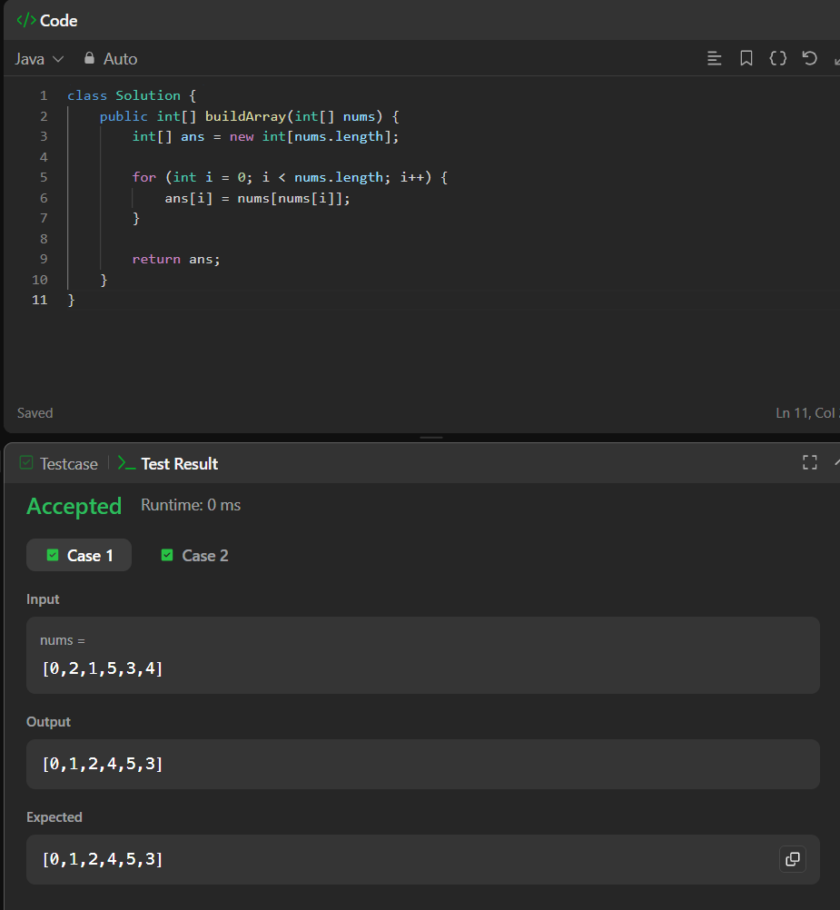
2. Shuffle the Array:
class Solution {
public int[] shuffle(int[] nums, int n) {
int[] ans = new int[nums.length];
int j = 0;
for (int i = 0; i < n; i++) {
ans[j++] = nums[i];
ans[j++] = nums[i + n];
}
return ans;
}
}
